

CHURCH OF CHRIST
TIPITAPA, KM 20
iglesiadecristokm20@gmail.com

To : Brothers
From : Tipitapa Church of Christ
Matter : Report of July, 2012
Date : Friday, the 3rd of August of 2012
Dear brothers.
Our greetings in Christ for all of you.
Greetings of all the brothers in Tipitapa.
Dear brothers, we are sending to them the report of the baptisms and works realized in this July, 2012. The church in Tipitapa and all the brothers send them thanks for his support in the prayers and in the economic part so that the gospel is preached in all the places of Tipitapa.
Our biggest interest as well as every preacher of Christ's church, is of looking for all the souls for Christ. To preach the gospel in the whole world.
Christ does not want that anybody loses if not that they all avenge to the repentance.
Thank you, brothers and always we request his prayers in everything.
God blesses them.

NAMES OF THE BAPTISMS IN TIPITAPA

PHOTOS OF THE BAPTISMS IN TIPITAPA

Number | Name | Last name | Date
1 | Jorge | Fuentes Pastran | 01/ July / 2012
2 | Carla | Mejia Vargas | 08/ July / 2012
3 | Luisa | Vargas Cajina | 08/ July / 2012
4 | Alex | Cajina | 22/ July / 2012
5 | Juan | Ruiz Miranda | 22/ July / 2012
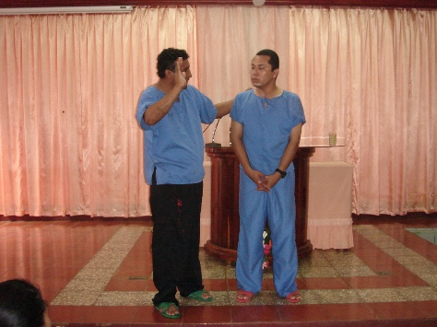
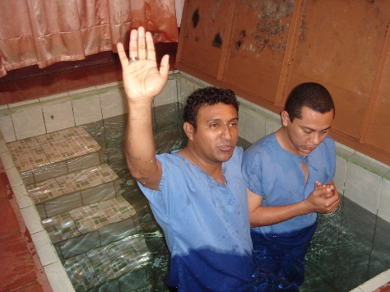

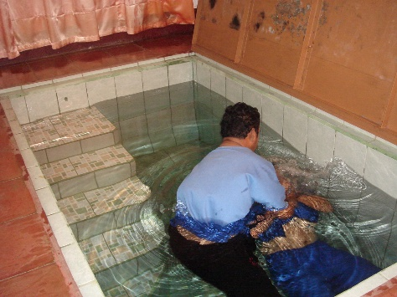
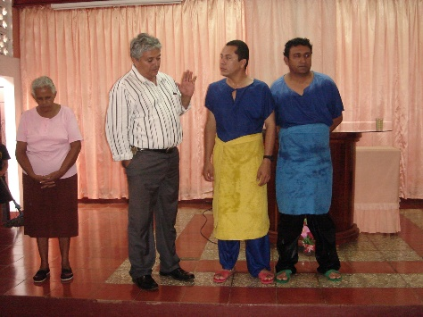

Here Jorge Fuentes is baptized by the brother Marvin and then the brother Francisco does the prayer
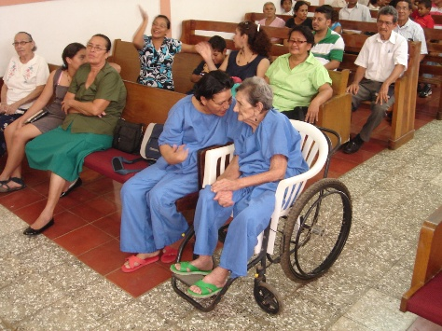
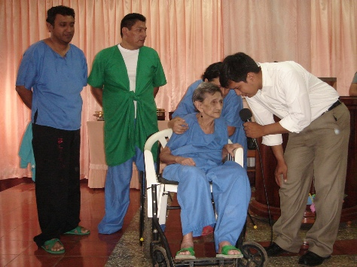

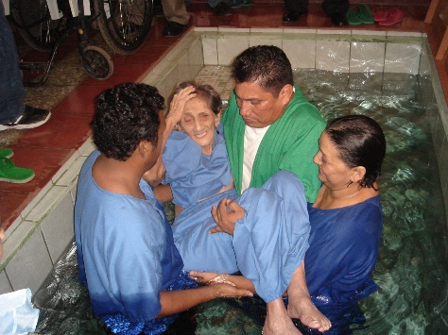
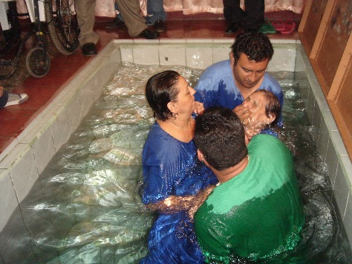

She is Luisa and the age of her is 87 years and his baptism is realized by the brothers Marvin and Alvaro Fuentes

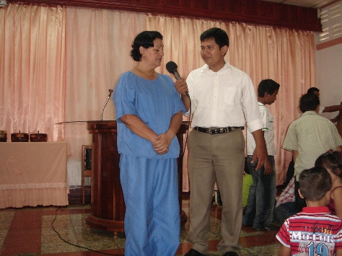
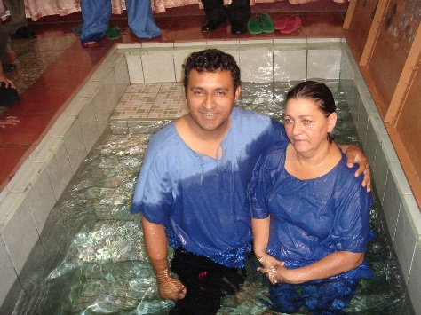

She is Carla and she is a Luisa's daughter, here the baptism is realized by the brother Marvin Miranda

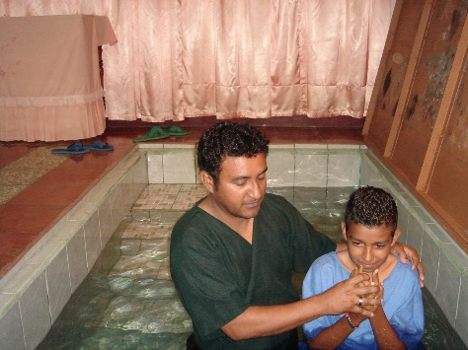
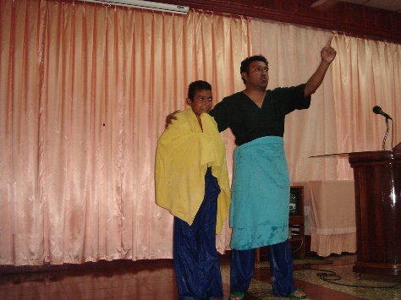

Here Juan Miranda is and here the baptism is realized by the brother Marvin


CHURCH OF CHRIST

In the Prison
IN SYSTEM PENITENSARIO THE MODEL

Dear brothers.
Report of the Prison.
On Tuesday, the 31st of July, we visit the brothers of the Prison to cheer them up across the word of our God; as result of the sermon two persons were baptized this day.
Also we share food and refreshments; we were a whole of 87 gathered persons this day.

The number of brothers in the Prison is always on the increase. We provide material Biblical to the person in charge of there in the prison to brothers who are leaders of the church in the prison so that they give Biblical classes to the newly baptized ones.

NAMES OF THE BAPTISMS IN THE PRISON
Number | Name | Last name | Date
1 | Isaías | Ordóñez Zeledón | 31/ July / 2012
2 | Erasmo | Contreras Gómez | 31/ July / 2012
Photos of the brothers that we visit the Prison
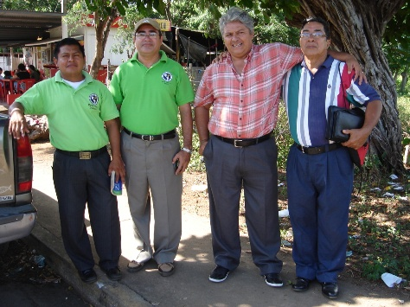
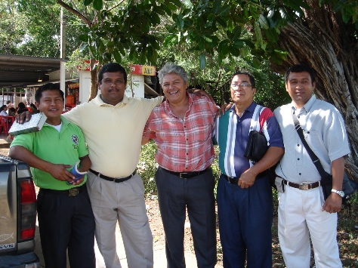

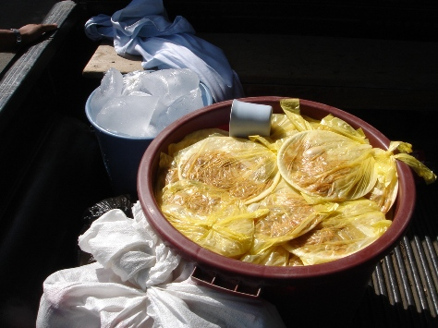
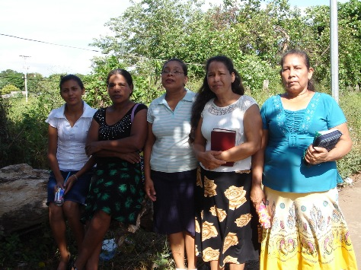

Brothers that we visit the prison and the food that were delivered by the sisters of the church


NAME OF THE PERSON BAPTIZED IN THE KM 38
CHURCH OF CHRIST
Km 38

Dear brothers.
We send report of the works realized in the Km 38.
The brother Carlos Gonzales, realizes works of evangelism
in (kilometer 38) every Wednesday early the brother visits the kilometer 38 firstly to give classes to new brothers in the faith with Biblical classes and then he attends to the persons in the evangelism and as result of this month; two persons who were baptized for the pardon of his sins.
The brothers of the church in the Km 38 already have their own property to construct a small chapel, they are very grateful by this blessing.
The brother Carlos Gonzales requests prayers for the future projects for this new work there in the km 38

Number | Name | Last name | Date
1 | Mauricio | Robleto Ortiz | 22/ July / 2012
2 | Raquel | Martínez Ochoa | 22/ July / 2012
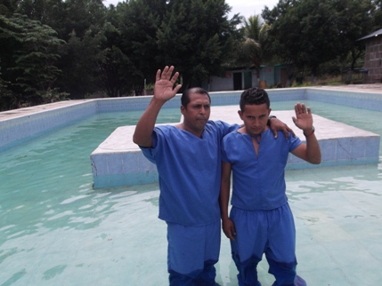
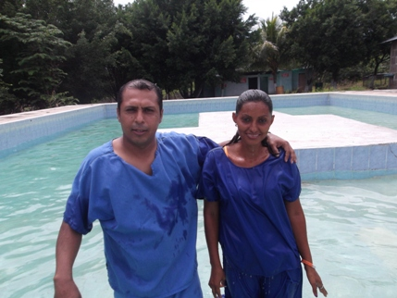

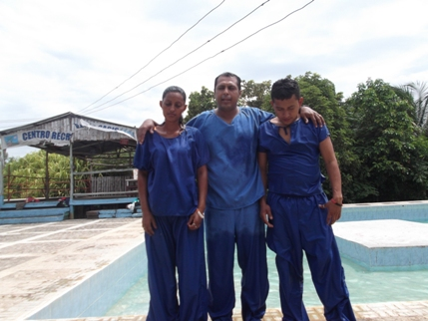
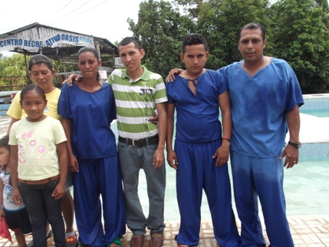

The brother Carlos Gonzales, along with two persons who were baptized


CHURCH OF CHRIST
IN THE PLEYWOOD

Report of the Pleywood.
Report of baptisms in the Pleywood.
The brother Elvis realized a baptism on Sunday, the 22nd of July of 2012.
Missis Blanca was baptized for the pardon of his sins.
The brother Elvis to realized a good work in the work of the Playwood in
education to the new brothers in the faith and preaching the word.

NAME OF THE PERSON BAPTIZED IN THE PLEWOOD

Number | Name | Last name | Date
1 | Blanca | Pichardo | 22/ July / 2012

PHOTOS OF THE BAPTISM IN THE PLEWOOD
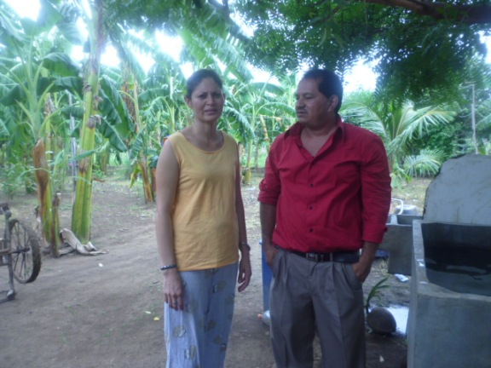
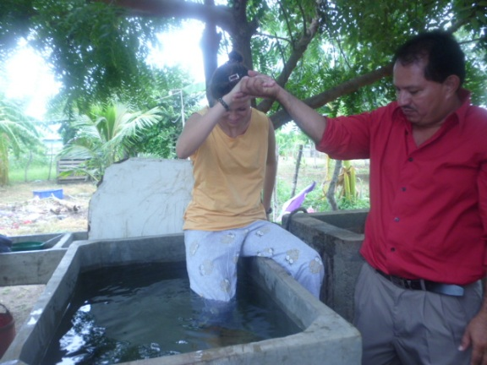

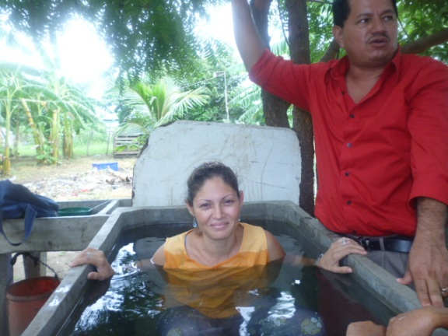
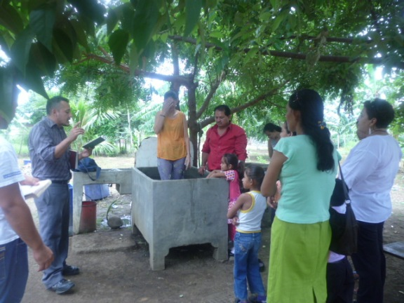
Missis Blanca is baptized by the brother Elvis


CHURCH OF CHRIST
IN SAN RAFAEL

Report in San Rafael
Missis Azucena is baptized in the baptistry of the church in Tipitapa, San Rafael this one at little distance of Tipitapa. She cannot walk due to a partial paralysis.
This work is attended by the brother Mario Vivas and collaborating Natanael Cajina.
They preached missis Azucena Rivas and then they moved her up to Tipitapa so that the baptism was realized
Number | Name | Last name | Date
1 | Azucena | Rivas | 28/ July /2012

NAME OF THE PERSON BAPTIZED IN SAN RAFAEL

PHOTOS OF THE BAPTISM OF SAN RARAEL
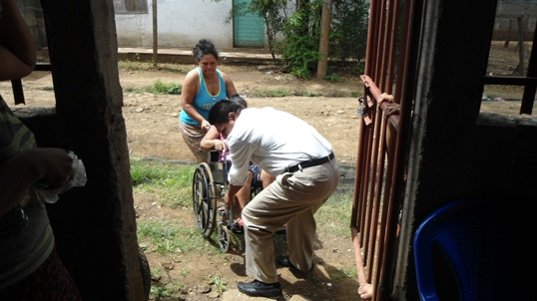
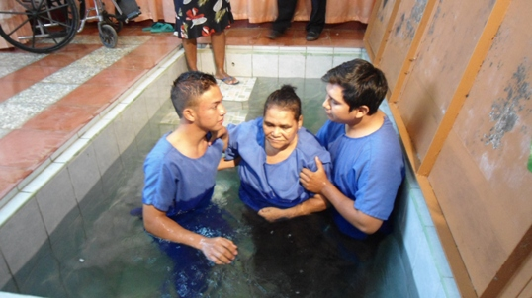
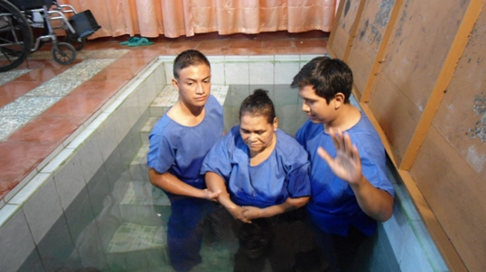
Moments in which she is moved to Tipitapa and then the baptism

