

CHURCH OF CHRIST
TIPITAPA, KM 20
iglesiadecristokm20@gmail.com

To : Brothers
From : Tipitapa Church of Christ
Matter : Report of June, 2011
Date : Friday, the 1st of July of 2011
Dear brothers.
Our most sincere greetings for all of you and for the glorious church of our Lord Jesús Christ.
Brothers, we are sending to them our works realized in June, 2011. For all of us it is of very much pleasure to be able to send it and to present to you the works of the preaching of the gospel realized in June and of the persons who have surrendered to Christ. Dear brothers in the Lord. For us it is of great happiness that the gospel is preached in all the places of Tipitapa and Nicaragua. We always request his prayers and that God blesses them very much.
The elders.

NAME OF THE BAPTISM IN TIPITAPA

Number | Name | Last name | Date
 | Graciela | Mejía Mejía | 05/ June / 2011
2 | Meyling | Rocha Jiménez | 05/ June / 2011
3 | Juana | González Hernández | 06/ June / 2011
4 | Jaquelín | Campos Hernández | 06/ June / 2011
5 | Iván | González Rodríguez | 10/ June / 2011
6 | Marling | Cucalón Gutiérrez | 10/ June / 2011
7 | Janeth | Gutiérrez Hernández | 10/ June / 2011
8 | Julieth | Galo Gutiérrez | 12/ June / 2011

Photos of the baptisms realized in Tipitapa, June, 2011

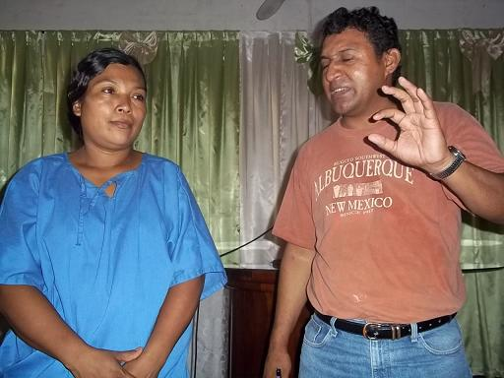
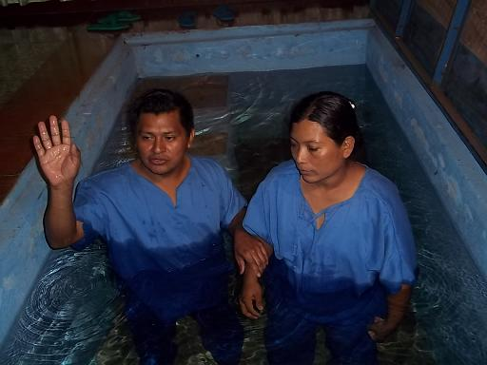

Here the brother Mario realizes the baptism to Juana

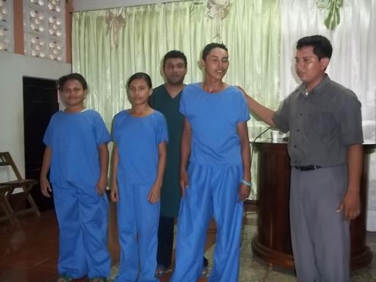
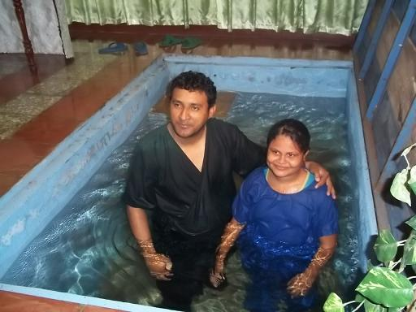

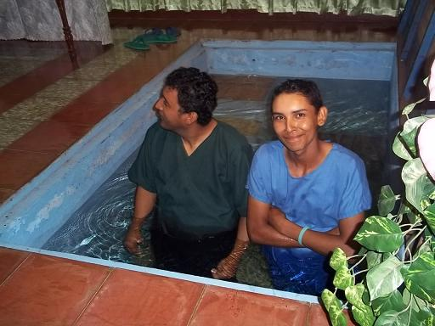
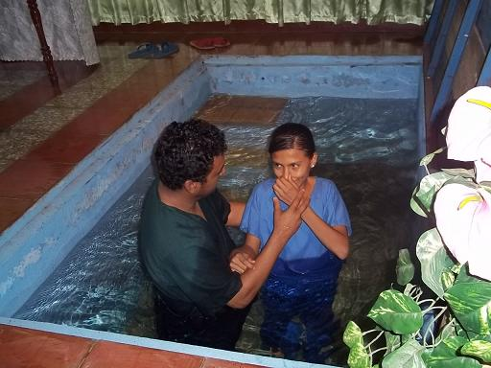

Here the brother Marvin realizes the baptism to Janeth, Ivan and Marling. They were baptized the same day.

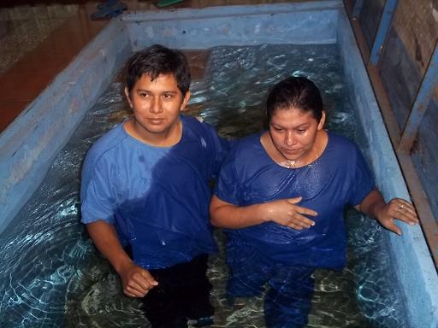
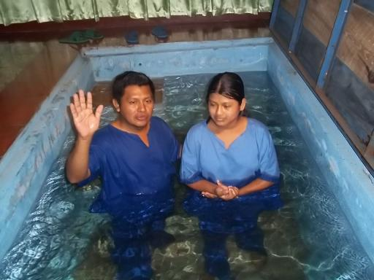

Here the brother Mario realizes the baptism to Jaquelín Here the brother Reinaldo realizes the baptism to Graciela



CHURCH OF CHRIST

In the Prison
IN SYSTEM PENITENSARIO THE MODEL
Report of the Prison
We were very satisfied, with all our internal brothers in the prison.
The gospel is preached and two persons will be baptized in the next visit that we will do to the prison. Two brothers in the prison that had separated from the church, returned for to continue in the church. Here we have to several brothers that the family does not visit them and we have a plan of looking for brothers in the church so that they sponsor each one with personal products as: soap, tiolet paper, dental pasta, and toothbrush, etc

Photos of the brothers that we visit the prison.
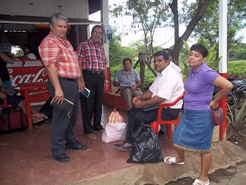
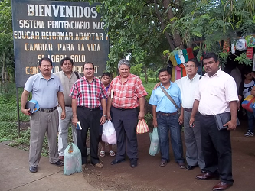

Group of brothers that we visit the brothers in the prison

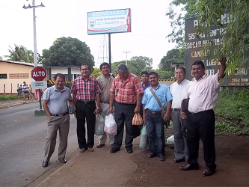
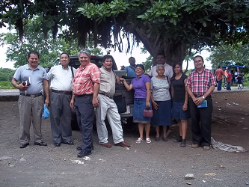

Here we are in the entry in the large door of the prison. This prison is the biggest of Nicaragua and it is of extreme danger. Here the work began the year 2000 and the authorities know already about Christ's church.

Report of baptisms in the Pleywood.
One of the works very nice is the Pleywwood not only for his green sceneries if not also for the preaching of the gospel. The Pleywood is a very good place to preach the persons. There there live many persons who fought in the war of Nicaragua for the 80s, they are demobilized of war and to all these persons the gospel of our Lord Jesus Christ will be preached them, so that they fight in the army of the Lord fighting Satan
CHURCH OF CHRIST
IN THE PLEYWOOD


Number | Name | Last name | Date
1 | Carolina | Obando Mendoza | 25/ June / 2011

Photos of Carolina's baptism in the Pleywood

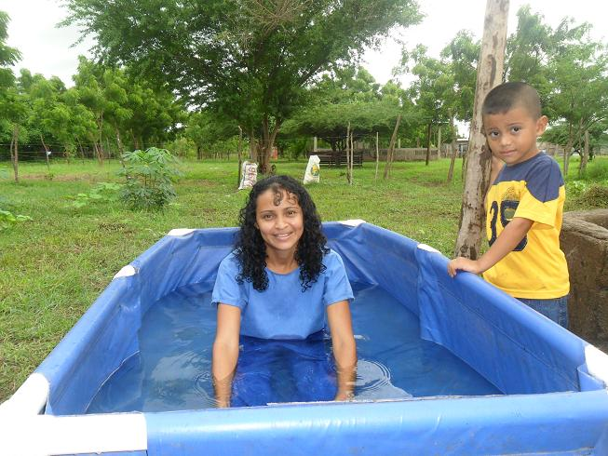
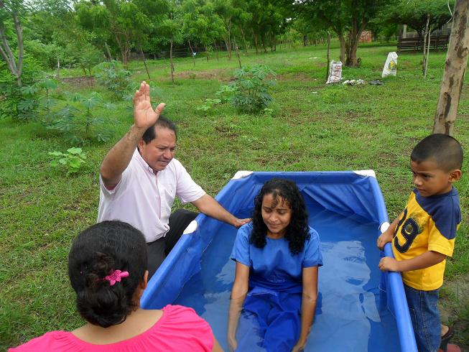

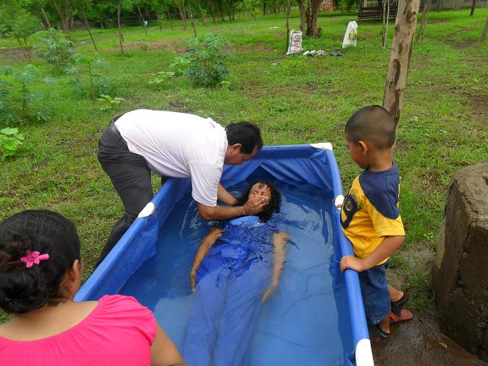
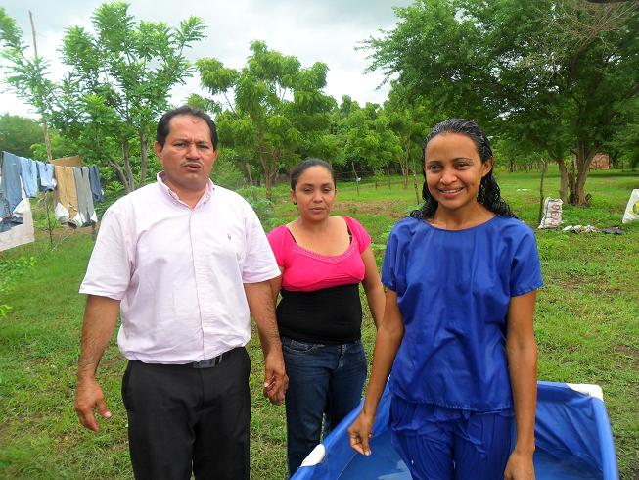

The brother Elvis, realizing the baptism to Carolina in the Pleywood, after a preaching.
The brother Elvis attends to this work on Wednesday and Sundays


CHURCH OF CHRIST
In the Banderas

REPORT OF THE BANDERAS
IN THE MONTH OF JUNE SE EVANGELIZO Y VISITO A THE BROTHERS, IN THE EVANGELISM THAT IS REALIZED ON WEDNESDAY WE HAD A BAPTISM LIKE RESULTED.
NAME: JOSE ANTONIO ORTIZ DIAZ RAMIREZ
AGE: 64 YEARS
DATE OF HIS BAPTISM: ON JUNE 8, 2011

NAMES OF THE PERSONS BAPTIZED IN THE BANDERAS

Number | Name | Last name | Date
1 | JOSÉ | ORTIZ DÍAZ | 08/ JUNE / 2011
PHOTOS OF THE BROTHER REINALDO IN CHARGE OF THE WORK IN THE BANDERAS, REALIZING THE BAPTISM TO JOSE

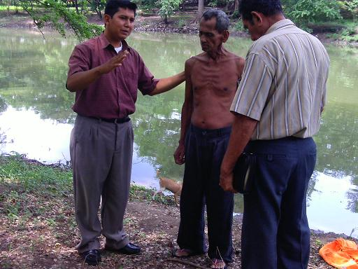
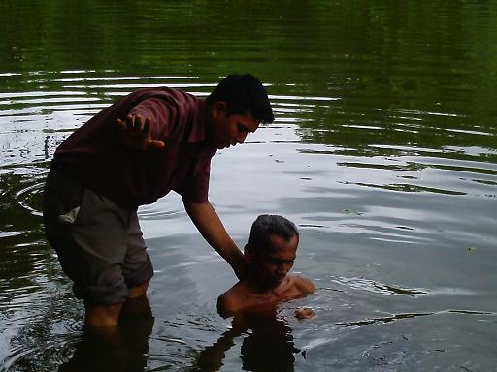

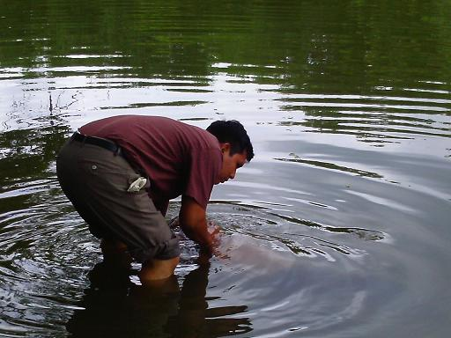
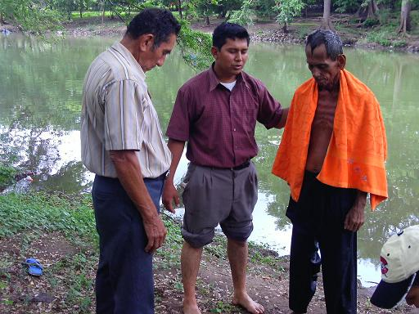
HERE THE BROTHER REINALDO REALIZES THE BAPTISM TO JOSE IN THE RIVER OF THE BANDERAS ALREADY ALMOST IN THE EVENING

Number | Name | Last name | Date
1 | Julio | Silva Madrigal | 29/ June / 2011


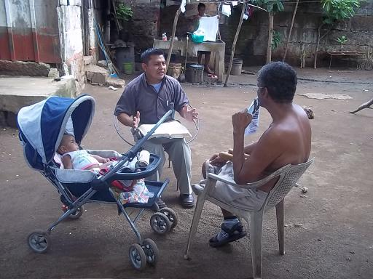
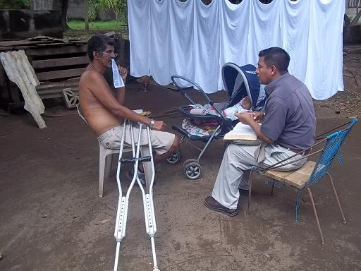
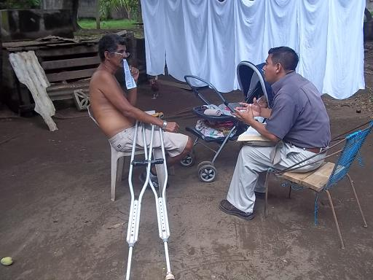
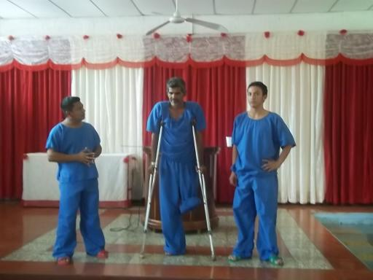
Report of baptism in San Rafael
San Rafael is one of the works that is located at little distance of the church in Tipitapa; it is by that the persons evangelized there in San Rafael are baptized in the baptistry of Tipitapa. On Wednesday evangelism is realized in all this sector and like result of the evangelism of this month was baptized a person. This is one of the churches with many brothers very faithful to the Lord.
There the brothers congregate in house of a sister every Wednesday for class Biblical and every Sunday for the adoration to God.
BAPTISMS IN SAN RAFAEL
Photos of the Baptisms in San Rafael
The brother Mario and Natanael preach Julio Silva and then it is baptized in the baptistry of Tipitapa. This occasion they had to enter the baptistry the brother Mario and Natanael to help Julio Silva.
CHURCH OF CHRIST
IN SAN RAFAEL

