

CHURCH OF CHRIST
TIPITAPA, KM 20
iglesiadecristokm20@gmail.com

OPENING OF NEW WORK IN VILLA SOLARIDAD. 2012

Christ's church in Tipitapa, gave beginning to the opening of a new work in this June, 2012. The place where this work begins is in VILLA SOLARIDAD at little distance of Tipitapa and the Pleywood. It is a community done by the government for the persons dignified in the winter of the year 2011.
Why the opening of a new work here?
First: it is a community with many inhabitants.
Second: Christ's church is not in this community.
Third: the persons want to hear of the gospel
The elders and the church we put in prayer the opening of this new work so that the Lord was opening doors of blessings and the Lord I listen to our prayers so that we could give beginning to the opening of this new work. Now Christ's church is present in this community and is preaching the gospel to the rest of inhabitants. The new work initiates with 13 persons that there were baptized more two brothers who live there. 15 brothers.
A day of Exploration in the area and two days of preaching.
With 18 brothers of Christ's church in Tipitapa, which they preached in Villa Solaridad

NAME OF THE BAPTISMS IN VILLA SOLARIDAD
Number | Name | Last name | Date
1 | Yamileth | Humbes Rodríguez | 21/ June / 2012
2 | Gersan | Sequeira Murillo | 21/ June / 2012
3 | Tatiana | Martínez | 21/ June / 2012
4 | Esmelda | Suárez Mairena | 21/ June / 2012
5 | Sandra | Mairena Flores | 21/ June / 2012
6 | Yolanda | Martínez Vallecillo | 21/ June / 2012
7 | Fernanda | López Garcías | 22/ June / 2012
8 | Melvin | Pérez Martínez | 22/ June / 2012
9 | Claudia | Picado Flores | 22/ June / 2012
10 | Carlos | Picados Flores | 22/ June / 2012
11 | Matea | Zamora Picado | 22/ June / 2012
12 | Walkiria | Hernández Calderas | 22/ June / 2012
13 | Givenchy  PHOTOS OF THE NEW WORK IN VILLA SOLARIDAD | Quiroa Humbes | 22/ June / 2012

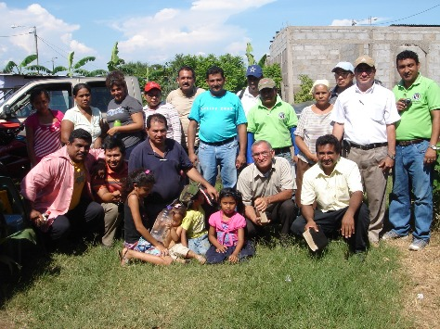
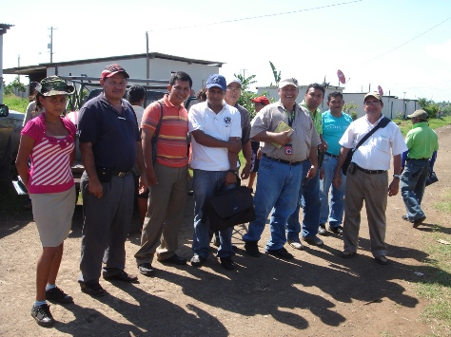

Group of brothers that we preach the gospel to the persons of Villa Solaridad
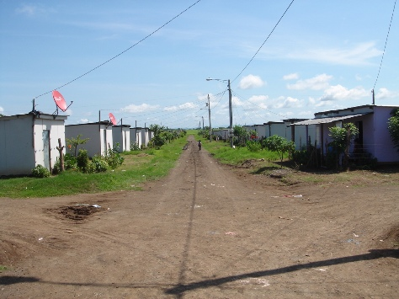
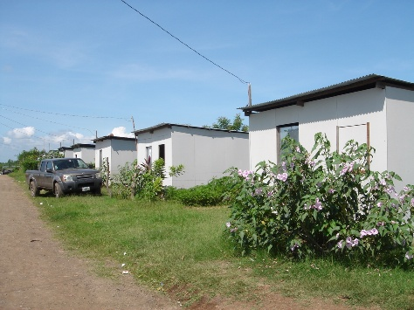

One of the streets of Villa Solaridad

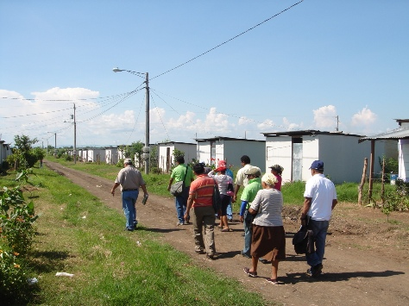
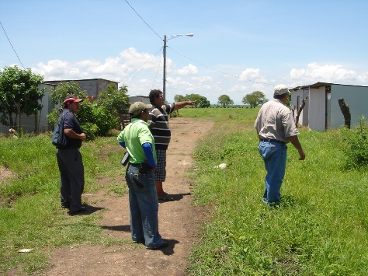

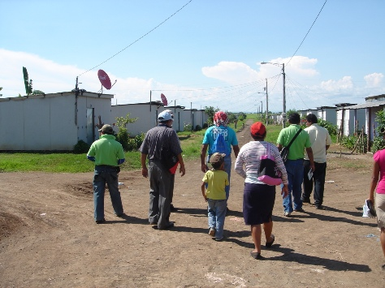
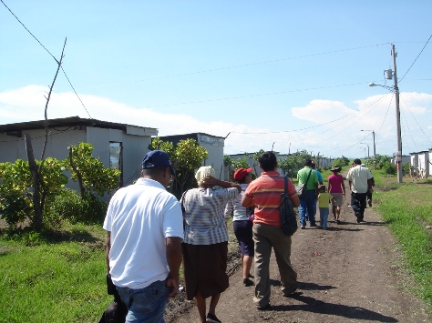

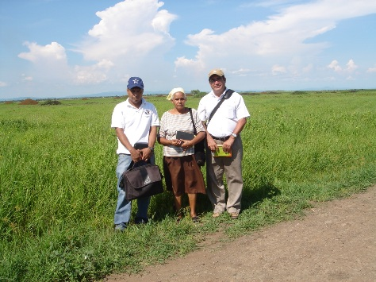
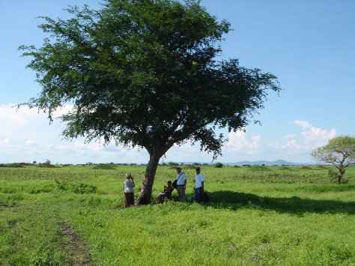

Here the group of brothers ready to preach the gospel to the persons who are in his houses and even under the shade of the trees

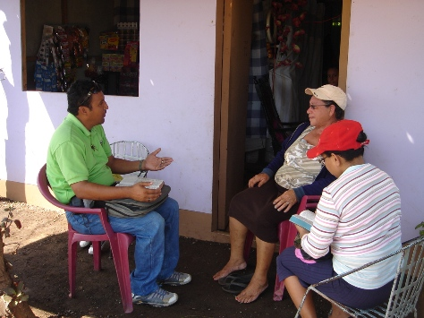
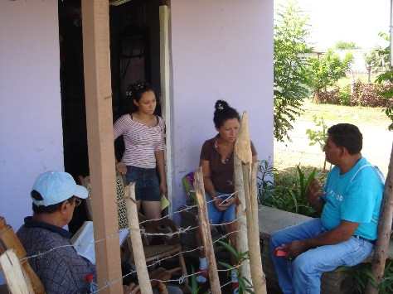

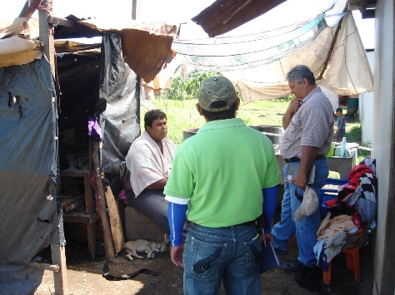
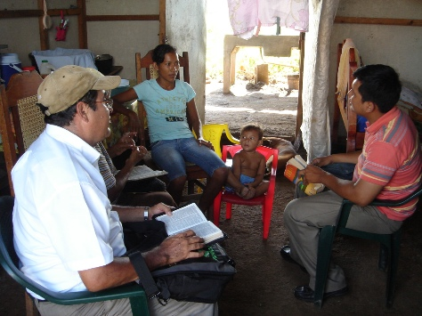

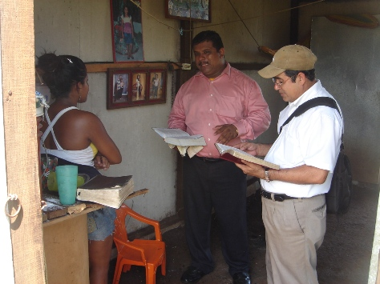
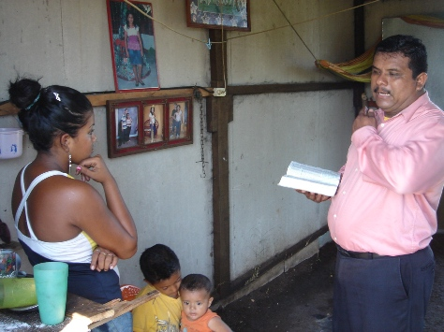

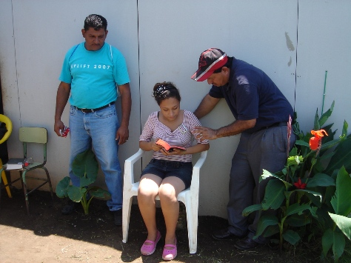
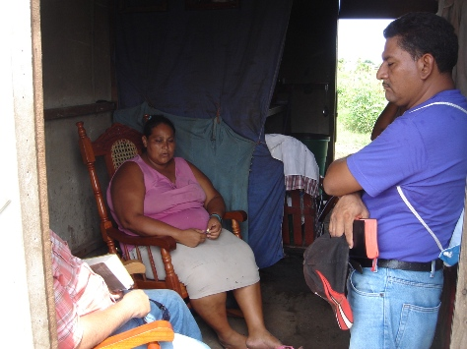

Groups of brothers preaching the persons and then these persons were baptized

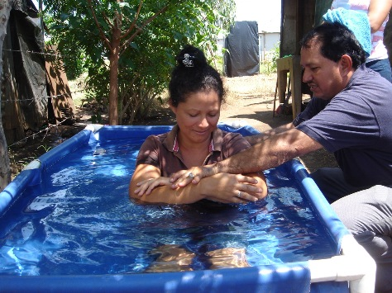
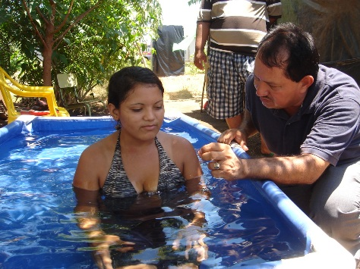

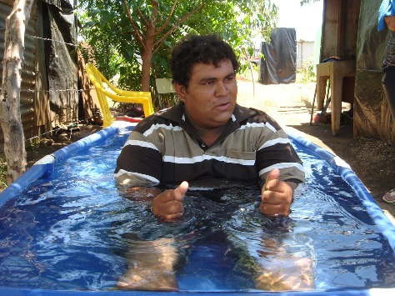
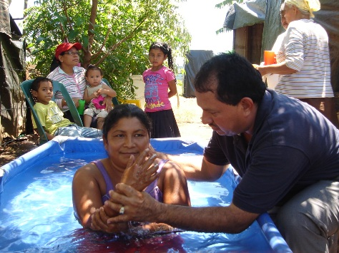

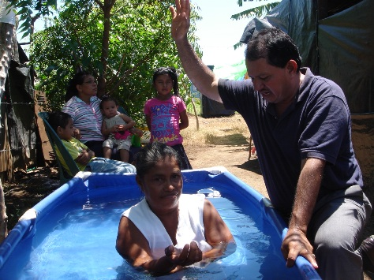
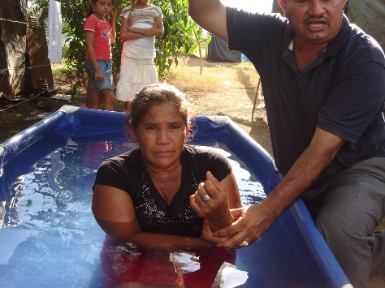

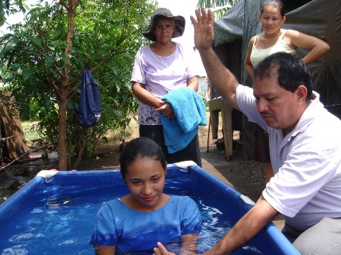
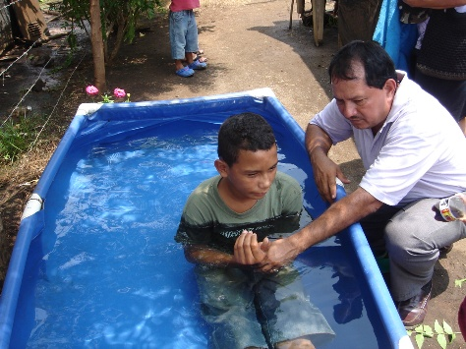

The baptisms in Villa Solaridad are realized by the brother Elvis

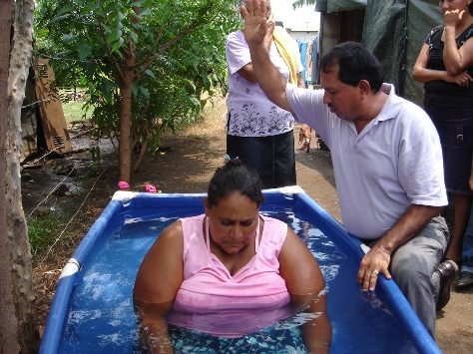
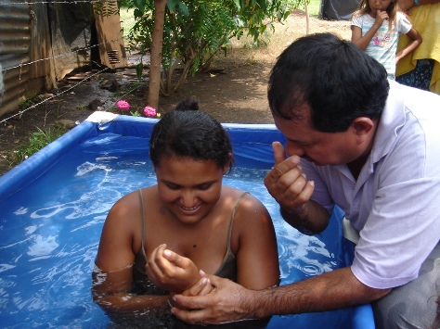

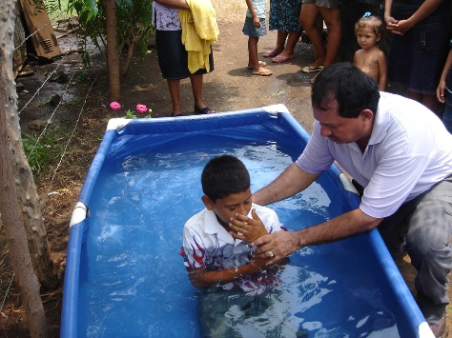
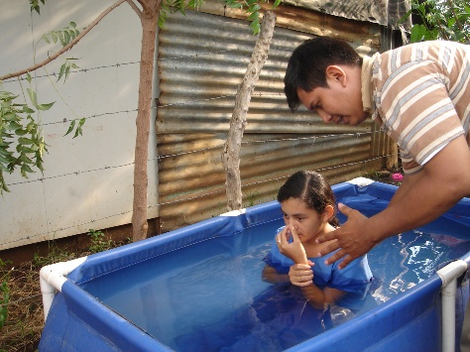
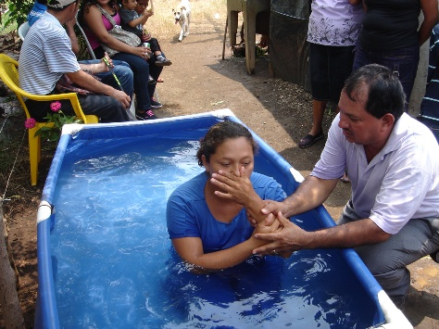
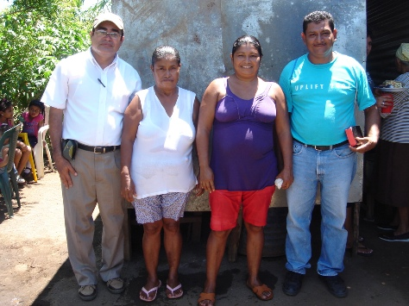
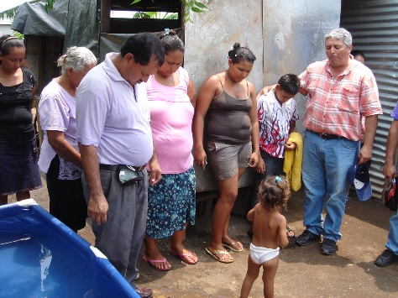
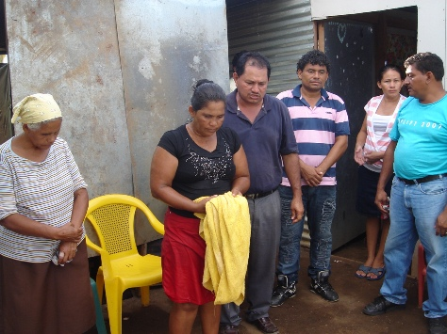

The brother Elvis baptizes and also the brother Reinaldo of shirt to streaks.
These are thirteen realized baptisms and our brother Francisco of squared shirt prays for the new baptized brothers
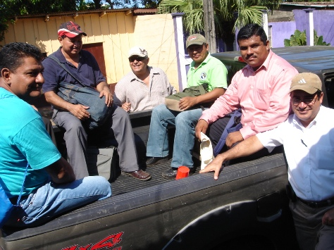
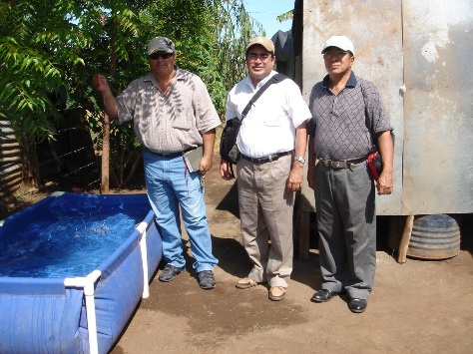

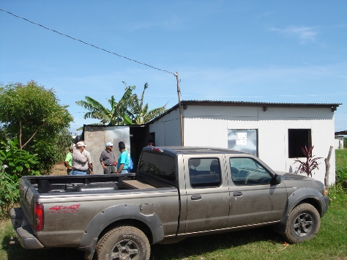
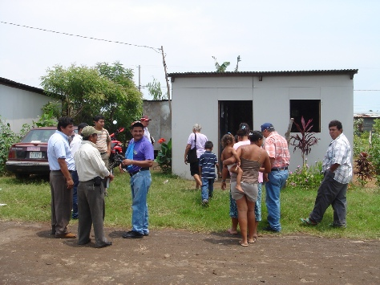
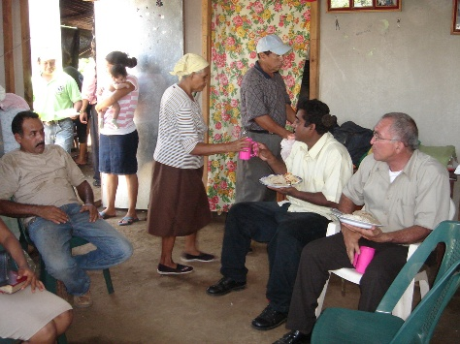
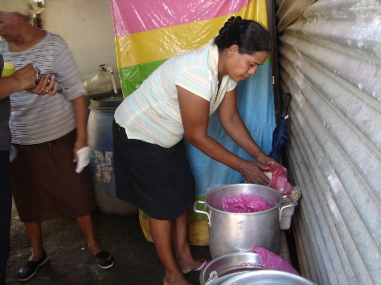
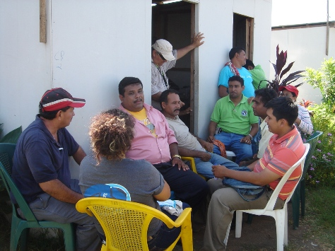
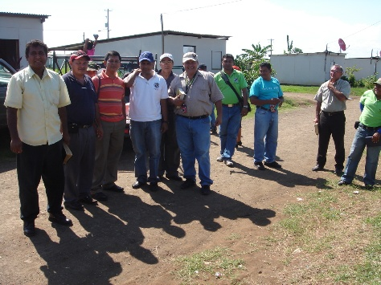
The trip for Villa Solaridad. From left side to right hand, Francisco, Ramón and Carlos
This is the house where the new brothers will be congregating for the time being until it is possible to buy a house in this place for the church
Hour of the lunch and the sisters prepare the food
Hour of the lunch and then to keep on preaching the persons

